From the home page click on “Online Service”
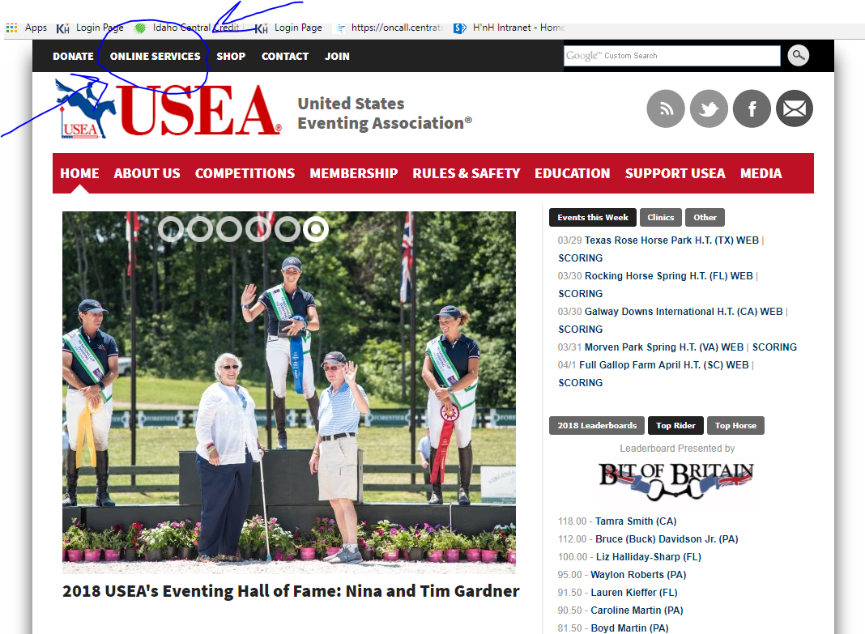
Then log in or create an account.
Once you are on your dash board you are going to look for “Create an Entry”
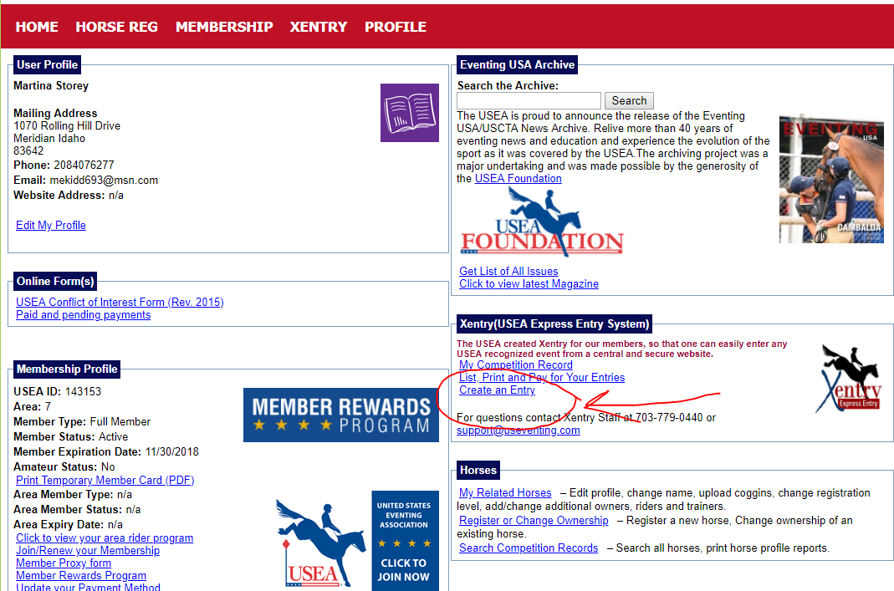
Then search in Area VII and it will say “Select Event”. Click on the Blue Select Event Box
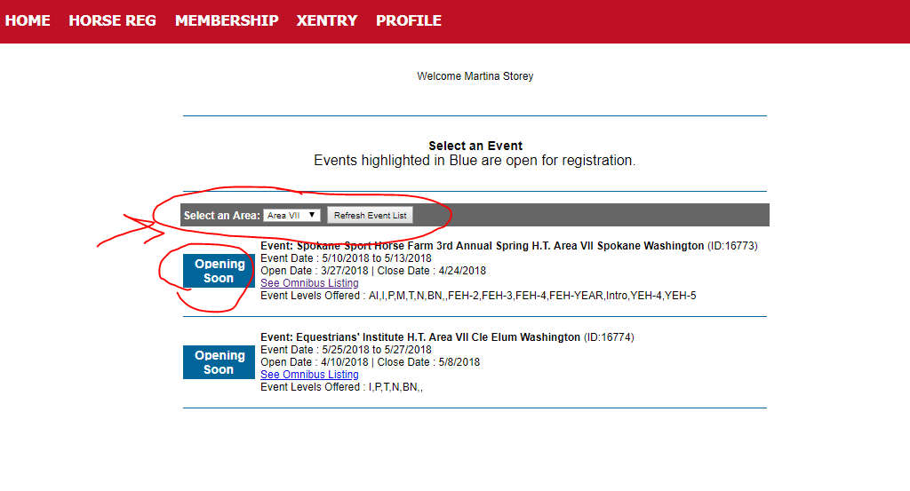
Then once the correct Event is selected you will select the rider….
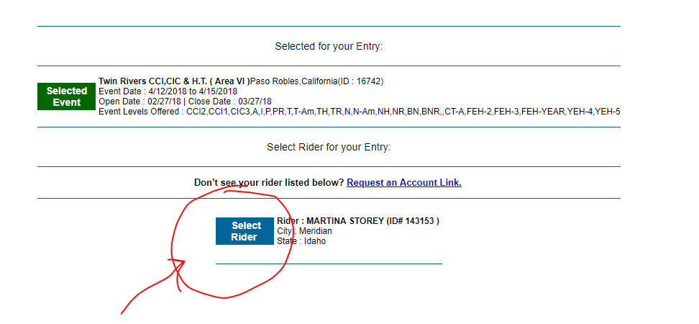
Then you will select your horse that is registered
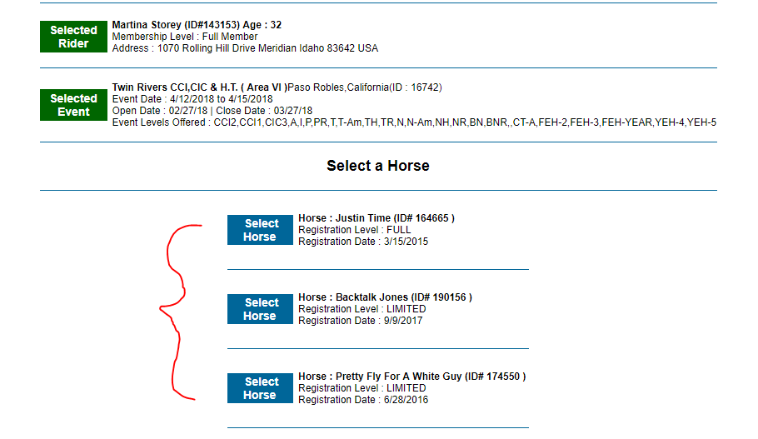

Then you will select your division and Xentry somewhat helps you know if you a re qualified by giving you two green yes’s.
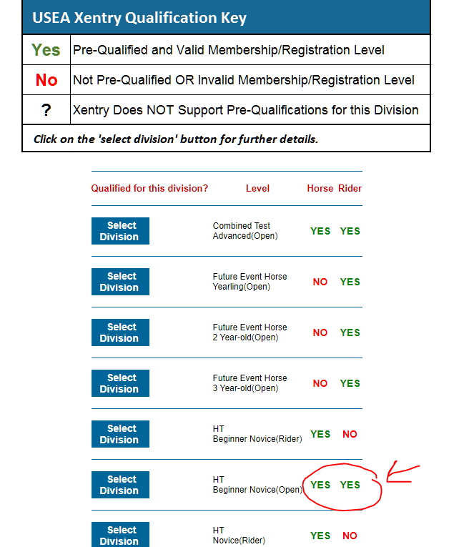
You will then Verify your information and select your division choices.
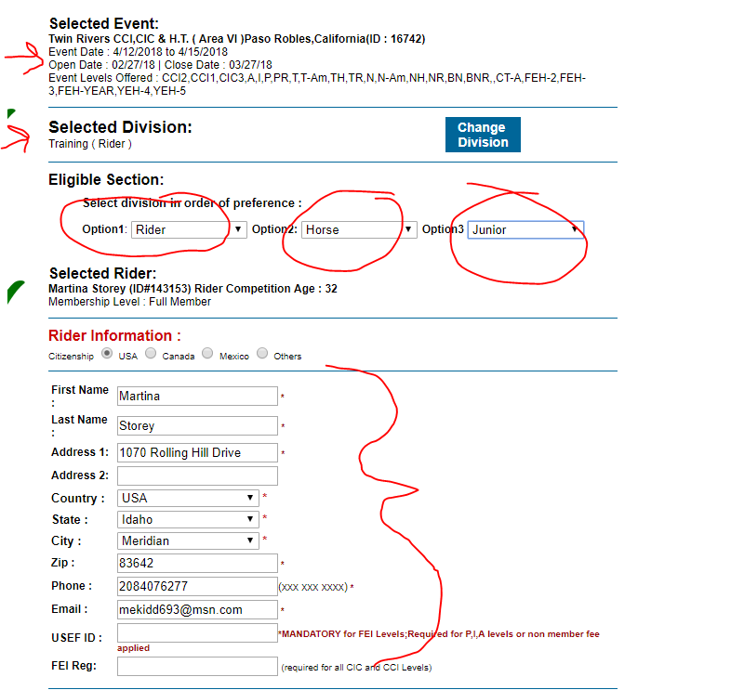
Lastly ;you will enter your stabling info and then finalize your entry….
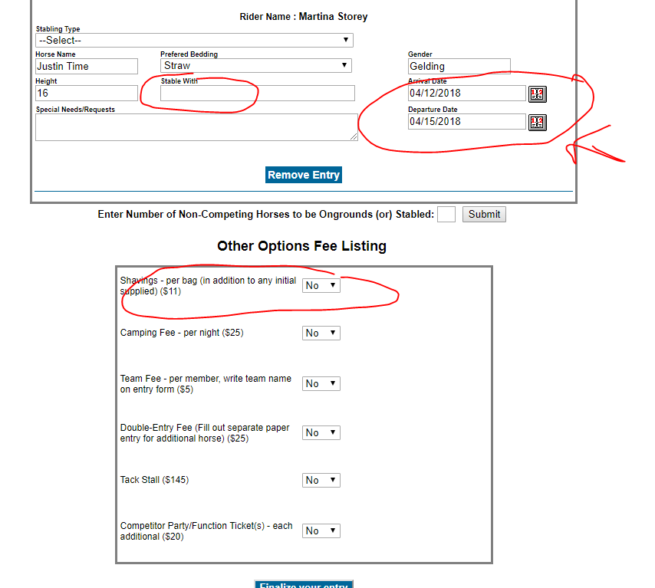
Once you have finalized you will need to pay with a credit card and then download and print the entry and the stabling form and snail mail it to the show secretary and you are done!

It gets easier I promise.

